­­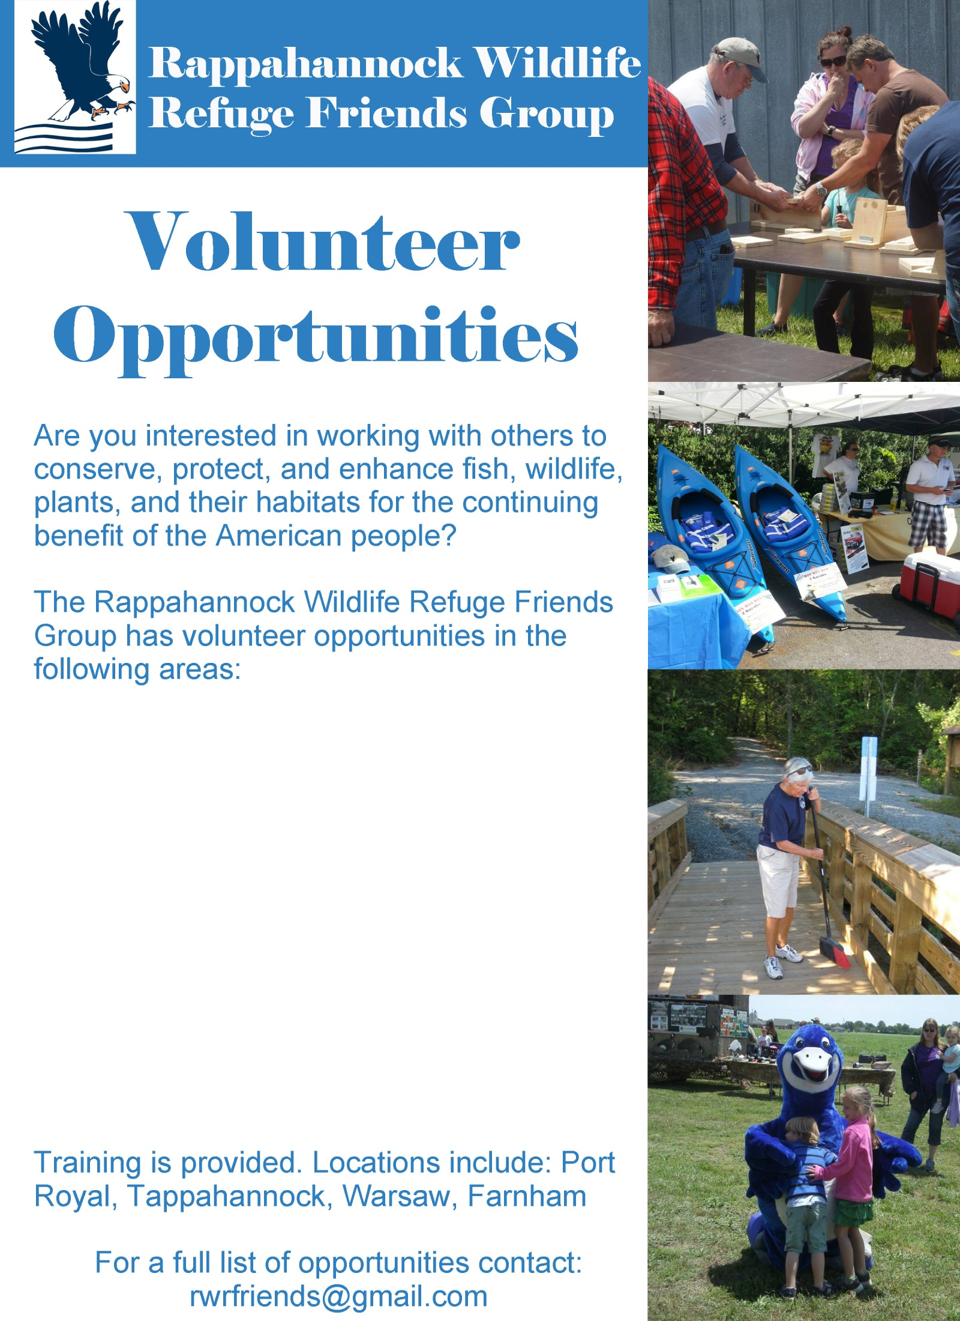

**\*Public Events**

**\*Trail Maintenance**

**\*Birding/Nature Walks**

**\*Educational Outreach**

**\*Administrative Support**

**\*Invasive Species Eradication**

**\*Carpentry Work**

**[outdoor decks, kiosks, etc.]**